|  |  |
| --- | --- |
|  | **Esce 426** |
|  | **Experiment 3 - Lab Report** |

|  |
| --- |
|  |
|  |

Group 20

Aqsa Ahmad – 260360630

Talib Mahmood Sheikh - 260350390

Table of Contents

1.0 Abstract 3

2.0 Problem Statement 3

3.0 Theory and Hypothesis 4

Accelerometer sensor LIS302DL 4

External interrupt/event controller (EXTI) 5

General Purpose input/output (GPIO) Pins 5

TIM3 Timer Clock 5

Pulse Width Modulation 5

4.0 Implementation 5

Accelerometer Sensor LIS302DL Initialization 5

Interrupt Configuration & Tap Detection 6

Calibration 7

LED Flashing 7

Moving Average Filter 8

Pulse Width Modulation 8

Tilt-Angle Calculation 8

5.0 Testing and Observations 8

Angle testing 8

LED Testing: 9

Selecting window size for moving average filter 9

Timer Testing 10

Calibration testing 10

6.0 Conclusion 10

7.0 References 10

8.0 Appendix 11

# 1.0 Abstract

The goal of the experiment was to use the on-board digital accelerometer, LIS302DL, of the STM32F4 Discovery board to implement a system that calculates tilt angles in 3 dimensions with a 4 degree accuracy as well as single tap detection. The system was to calculate angles in real time with a frequency of at least 25Hz using the board's internal hardware timers. In addition, the LIS302DL sensor had to be configured to detect a single tap and showcase a pattern by flashing the board's LEDs at each tap. The sensor was re-calibrated and the acceleration values obtained on each of the X, Y and Z axes were filtered using the *moving average* filter from the previous lab. Subsequently, pitch and roll angles of the board were calculated and displayed using the SWD debug interface. It was observed that once calibrated and subsequently filtered, the accelerometer was able to measure pitch and roll angles with an accuracy of 1 degree.

# 2.0 Problem Statement

To achieve an optimal implementation of a system capable of accurately measuring tilt angles and detecting/displaying single taps as well as triggering interrupts to run both processes concurrently, the following challenges had to be addressed:

* Configuring the on-board accelerometer, LIS302DL, to measure acceleration
* Calibrating the accelerometer by calculating the offset associated and incorporating sensitivity of the sensor on each axis
* Initializing the *TIM3* clock interrupt timer to generate interrupts and obtain acceleration readings on 3D coordinate axes
* Calculating pitch and roll angles from the calibrated and filtered X, Y, Z readings
* De-noising the calibrated readings by passing them through the *moving average* filter and determining an optimum window size for the filter by comparative analysis of noisy and filtered signals
* Managing interrupt priority
* Representing tap state through the board’s four LEDs by configuring the board’s appropriate (GPIO) pins;
* Use a hardware timer to implement PWM
* Programming the LEDs to turn on/off at each subsequent tap

# 3.0 Theory and Hypothesis

## Accelerometer sensor LIS302DL

The board's LIS32DL accelerometer is a low power, linear accelerometer with 3-axis output (X, Y and Z axes) and measures the projection o the gravity vector on the axes. It has three sensing elements whose information is provided through an I2C/SPI interface which is the inter-Integrated Circuit standard that uses two wires for bidirectional transmission, the Serial Data Line (SDA) and the Serial Clock (SCL), and connects low-speed peripherals to the microprocessor. The accelerometer also has two programmable interrupt sources which can be employed to generate an interrupt when a pre-defined acceleration threshold is exceeded by any of the axes. [1]

The values of X, Y and Z are analog values which have to be converted to Pitch and Roll angles using the following formulas:

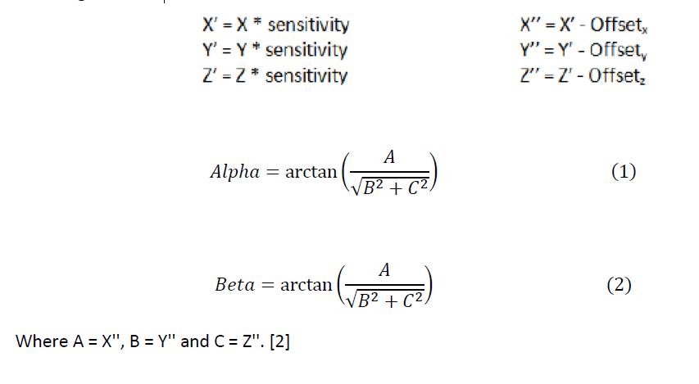

For the accelerometers in the LIS302DL sensor, the power mode was set to active and the data rate to 100 Hz. The X, Y and Z axes were enabled and then scale was chosen with the sensitivity of 0.018mg/LSB.

The calibration implemented was static to save time and for general convenience when testing the interrupts. It was carried out by holding the board in a fixed position and having the user press a button to latch the accelerometer readings and store them in an array. A vertical surface (box) was used to ensure that the board was as close to 0 degrees vertically as possible while calibrating and a horizontal 4 surface (table) was used when latching the horizontal values. 6 different positions were used for calibration. Each of the three axes was placed in a position where it would be facing either positive g-force or negative g-force (g = acceleration due to gravity). The calibration was carried out several times and the offset values were averaged out to account for any possible error which may have arisen due to incorrect placement in any of the 6 positions.

## External interrupt/event controller (EXTI)

The EXTI controller can be used to generate up to 23 interrupt requests. It has a dedicated status bit for each interrupt line. Each interrupt line can be configured to select a trigger event, whose priority can be pre-set. [1]

For our purposes we used the external interrupt to configure the interrupt thrown by the tapping function of the accelerometer.

## General Purpose input/output (GPIO) Pins

Each of the GPIO pins can be configured by software as output, input, or as peripheral alternate function. Most of the GPIO pins are shared with digital or analog alternate functions.

### TIM3 Timer Clock

TIM3 is an advanced control timer which consists of a 16-bit counter controlled through a 16-bit register that can count up, down or both. The counter clock frequency can be divided by a *prescaler* by any factor between 1 and 65536. A main feature of the timer is the generation of interrupts based on counter overflow/underflow, internal/external trigger or counter initialization. [2], [3]

To set the interrupt of this counter, the Nested Vector Interrupt Controller (NVIC) was configured by a pre-scale factor. To get the desired rate, the timer clock frequency was divided by multiple of pre-scaler value and period value [2].

TimerClockingFrequency / (Period × prescalar) = desired rate

## Pulse Width Modulation

This is a modulation technique that regulates the width of the pulse (pulse duration) based on modulator signal information. The average value of voltage fed to the LEDs is controlled by switching the LEDs On/Off at a high frequency. The longer the switch is on compared to the off periods, the higher the power supplied to the load is [3]. Therefore the intensity of the LEDs can be changed using this technique.

# 4.0 Implementation

## Accelerometer Sensor LIS302DL Initialization

To measure tilt angles and detect taps using the *STM32F4Discovery* board, the on-board *LIS302DL* accelerometer had to be properly initialized. This is done in the *init_acc* function which is called from the *main* function. The major settings included enabling the accelerometer on the X, Y and Z axes with low power mode and a data output rate of 100Hz. The accelerometer interrupt generation is configured in the *config_acc_interrupt* function. The main configuration settings in initializing the accelerometer are shown below,

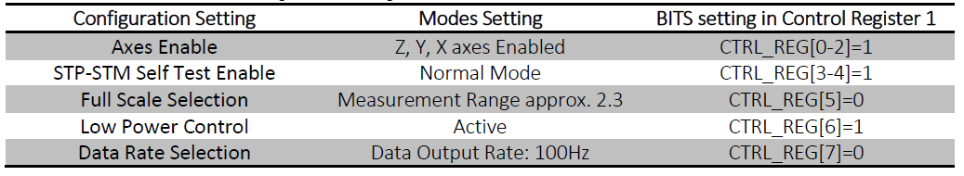

**Table: Configuration settings**

This sets the power mode configuration to low power active mode. The data rate is set to 100Hz rather than 400Hz. As the accelerometer is read at a rate of 25Hz, there is no need for a 400Hz data rate.

We also set the Full scale to 2_3 so that the accelerometer can detect changes of $± 2$ gravities. The self test allows the accelerometer to apply a known force to the sensors and measuring the deflections. We set this to normal as this would block the actual gravity measurements. After configuring the accelerometer data was read from it and stored in an array. These values are then passed through the moving average filter and the resulting coordinates used to calculate the pitch and roll.

## Interrupt Configuration & Tap Detection

The interrupt handler is also configured such that it sets a flag when the interrupt function is entered. This flag will be read by the main function and will inform it to sample values from the accelerometer. When the values are sampled, the main function resets the flag. The values are later calibrated and passed through the *moving average filter.* The filter depth was set to 10 as a larger number would increase the delay of the average calculation by a factor of 1/25s.

The single click interrupt is then configured so that it is generated when values are above a certain threshold (for each axis) only within a certain time limit. The threshold (for each axis) and time limit are also configured. This is done by writing directly to the appropriate registers of the accelerometer the bytes corresponding to the desired settings.

The EXTI Line0 Interrupt is set and enable to lowest priority. The EXTI_Line0 interrupt is enabled and set to the lowest priority. This shows that the external interrupt is set on line 0 with positive edge triggered and NVIC set to priority 1. The purpose of setting EXTI channel with low priority than the timer is that the highest priority will be given to the angle calculation which is important of all.

Next the main function checks the interrupt flag and the tilt function sets the LED flashing if there is no tap, and if there is tap then it dims the LED using pulse width modulation.

The external interrupt channel preemption priority was set higher than the timer to give tap detection the highest priority. Whenever a tap was detected, the external handler was implemented. In the handler, a tap was determined to be a single click whenever the logic AND of the value read from the click register with 0x2A was a non-zero number. Similarly, a tap was determined to be a double click if the logic AND with 0x15 returned a non-zero number. The following shows EXTI Line0 interrupt configurations,



**Table: EXTI configuration**

In the interrupt handler, a flag is set. This flag will be checked by the main function and the main will reset it after having flashed the LEDS. The flashing will be handled by the *output_display* function created in the Lab-2 to support code modularity.

To ensure that the accelerometer was being read at the desired rate, we configured Timer3 to generate an interrupt with the desired frequency (25Hz). Based on this methodology, we configured the Nested Vector Interrupt Controller to allow the timer to throw an interrupt.

## 

## Calibration

The LIS302DL accelerometer was re-calibrated to minimize inherent inaccuracies as a result of design limitations and manufacturing technology, and to ensure accurate readings by correcting deviations. The calibration was done using the least square method. A brief description of the method used is given under. The calibration procedure is as follows:

There are 3 matrices of interest and are defined as follows,

**Matrix Y:** Represents known earth gravity vector

**Matrix W:** represents sensor data corresponding to the six stationary positions

**Matrix X:** It is a matrix of 12 calibration parameters

The following equations are used to compute Matrix X

Y = w·X

$$X= {\left[w^{T}∙w\right]}^{-1}∙w^{T}∙Y$$

A Matrix Y was defined as shown below,

$$Y=\left(\begin{matrix} 0 & 0 & 1 \\ 0 & 0 & -1 \\ 0 & 1 & 0 \\ 0 & -1 & 0 \\ 1 & 0 & 0 \\ -1 & 0 & 0\end{matrix}\right)$$

The board was positioned in the 3D coordinate plane and corresponding values were read from the sensor and a resulting W matrix was drafted as shown below,

$$w=\left(\begin{matrix} 35 & 0 & 965 & 1 \\ 18 & 36 & -1026 & 1 \\ - 43 & 995 & 28 & 1 \\ 32 & -955 & -52 & 1 \\ 1006 & 18 & -84 & 1 \\ -1033 & -64 & 28 & 1\end{matrix}\right)$$

The last row of the X matrix gives us the offset values which we subtracted from the raw sensor values to get the calibrated sensor values. We then used the calibrated values to calculate the pitch and roll.

Using Matlab, matrix X was obtained as shown below,

$$X=\left(\begin{matrix} 0 & 0 & 0 \\ 0 & 0 & 0 \\ 0 & 0 & 0 \\ 0 & 0 & 0 \\ 0 & 0 & 0 \\ -0.0139 & -0.0275 & 0.0320\end{matrix}\right)$$

## LED Flashing

LEDs were used to showcase the changes in the Pitch and Roll of the STM32F4 discovery board. The magnitude of the pitch and roll determined the frequency of flashing. This allowed certain tilts to be depicted by certain intensities of flashing lights. The range of the pitch and roll was divided into four regions. Respective LEDs were flashed for respective cases that entailed the following tilts,

* Left tilt
* Right tilt
* Backward tilt
* Forward tilt

## Moving Average Filter

After calibration, each new sample is passed to the moving average filter designed in Lab-1 to improve its Signal-to-Noise Ratio (SNR). An optimum window-size of the filter was chosen based on analysis done in Lab-2 of filtered vs. non-filtered values on the filter design. An array size of 10 was chosen.

## Pulse Width Modulation

We used the Pulse width modulation we implemented in the previous lab but we used a hardware timer in this lab. TIM4 was used as alternative functionality was required to control the LEDs by the timer. Output compare mode of TIM4 was used and each LED was configured to a single channel. Thus by setting the values of the brightness directly to the capture/compare register, PWM function was displayed by the LEDs.

## Tilt-Angle Calculation

After de-noising, *Calibrated Reading* values for the X, Y and Z axes were used to calculate the Alpha (PITCH) and Beta (ROLL) angles in degrees for tilt detection

# 5.0 Testing and Observations

## Angle testing

Testing was also carried out on the angles calculated from the filtered values. The accelerometer was placed in positions of known orientations and the values of the pitch and roll angles before and after filtrations were compared:

|  |  |  |  |  |
| --- | --- | --- | --- | --- |
| **Actual Angle** | **Pitch Before Filtration** | **Roll Before Filtration** | **Pitch After Filtration** | **Roll After Filtration** |
| **0** | 1.81 | 1.08 | 0.81 | 1.08 |
| **-30** | -28.16 | -28.51 | -28.45 | -28.98 |
| **-60** | -57.76 | -57.94 | -58.64 | -59.59 |
| **30** | 27.37 | 27.54 | 28.27 | 29.17 |
| **60** | 57.26 | 58.63 | 58.07 | 58.14 |

As can be seen from the table, there was a slight increase in the accuracy of the angles calculated after filtration.

We tested the tilt angle by using a protractor to position the board on the table at different angles. We displayed the real time Pitch and Roll into a printf window. The pitch and roll were initially accurate to 8º. After implementing the calibration the accuracy improved to nearly 4º.

The following depicts LEDs that turn on relative to the specified orientation of the board based on alpha and beta angles.

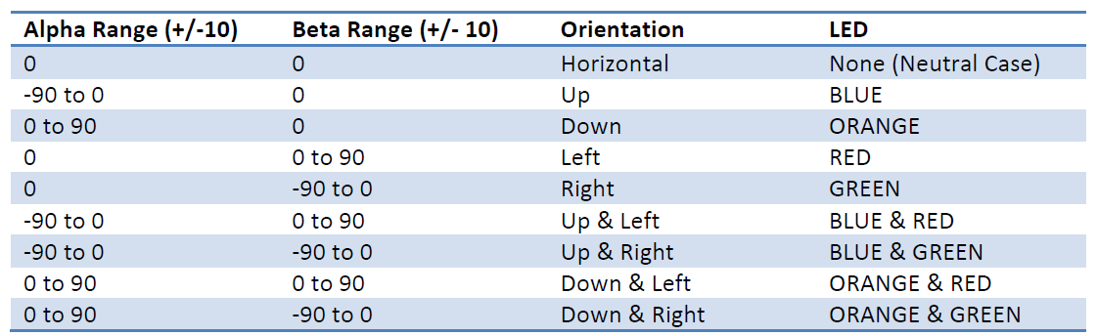

**Table: LED configuration on various alpha and beta ranges**

## LED Testing:

The operation of the LEDs was tested over various ranges of alpha and beta angles to ensure correct functionality. Input values were pre-set and the resulting LED patterns were noted. The following shows that the correct LEDs lit relative to the alpha and beta values.

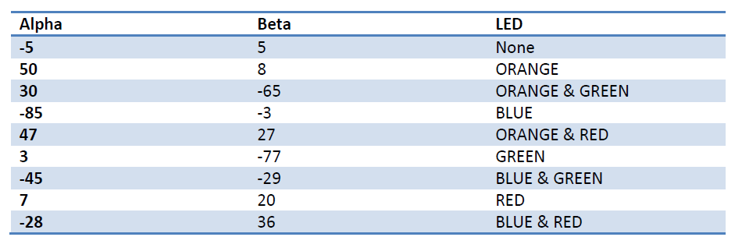

**Table: LED testing over various alpha and beta values**

## Selecting window size for moving average filter

The test was performed after angle calculation since the angle values are easier to observe than raw accelerometer readings centered on +/- 1 g. In practice, accelerometer readings are filtered before tilt angle calculation.

Systems with large window sizes lead to a slow, unresponsive system. This inefficiency and lack of responsiveness was clearly visible when we set the window depth values greater than 20.

Systems with very small window sizes are produce curves that are not smoothed out and the filtered temperature values vary as much as the non-filtered values; for example, if we set the depth very low for example, equal to 3: then filtered and non-filtered plots are nearly identical.

Systems with intermediate values of depth (d=10, d=20), a filtered temperature curve is obtained that accurately follows variations in the measurements, and at the same time, eliminates variations due to inefficiency of the sensor readings. Graphically, the filtered curve is within the boundaries set by the non-filtered curves at any time and is smoothed out.

The optimal value for the window size of the filter is depth d=10 because at this value, a fast responsive system is observed that smoothes out variations due to sensor inaccuracy.

## Timer Testing

We created a counter in the interrupt handler. The time it took to count to 20000 was noted using break points. The frequency of the timer was then verified using the following equation: $Frequency=\frac{20000}{Time}$

## Calibration testing

Testing of the calibration was done by taking values of offset X, offset Y, offset Z multiple times and then taking the average of these values to calculate the original offset.

# 6.0 Conclusion

The goal of the experiment was to use the on-board digital accelerometer, LIS302DL, of the STM32F4 Discovery board to implement a system that calculates tilt angles in 3 dimensions with 4o accuracy as well as single tap detection. Based on the particular implementation to achieve this goal, the tests performed and the observations made, it was concluded that tilt angle values could be measured within an accuracy of +/- 1 degree through proper calibration, de-noising of raw data, and applicable Pitch and Roll angle equations. An optimum filter window-size of d=10 gave the most favorable signal-to-noise ratio. In addition, the accelerometer could be configured to allow for single tap detection and its sensitivity controlled by setting threshold values in the external interrupt handler. Also, the accelerometer sensor was configured to use the single tap feature detection to switch from normal mode to PWM mode depending on the external interrupt.

# 7.0 References

STMicroelectonics. “LIS302DL Datasheet” Technical Resources http://www.st.com/internet/com/TECHNICAL_RESOURCES/TECHNICAL_LITERATURE/DATASHEET/CD00135460.pdf .

"ST Application note AN2579, LIS302DL 3-axis digital MEMS accelerometer translates finger taps into actions ." http://www.st.com/internet/com/TECHNICAL_RESOURCES/TECHNICAL_LITERATURE/APPLICATION_NOTE/CD00163557.pdf.

"ST Application note AN3182, Tilt measurement using a low-g 3-axis accelerometer." http://www.st.com/internet/com/TECHNICAL_RESOURCES/TECHNICAL_LITERATURE/APPLICATION_NOTE/CD00268887.pdf .

STMicroelectronics. "RM0090 Reference manual." In *STM32F405xx, STM32F407xx, STM32F415xx and STM32F417xx; advanced ARM-based 32-bit MCUs*, STM32F405xx Electrical Characteristics Data sheet section 2.2.35, by Doc ID 018909 Rev 1. STM & ARM, 2011.

STMicroelectronics. "RM0090 Reference manual." In *STM32F405xx, STM32F407xx, STM32F415xx and STM32F417xx; advanced ARM-based 32-bit MCUs*, section 5.3.2.1, by Doc ID 018909 Rev 1. STM & ARM, 2011.

STMicroelectronics. "RM0090 Reference manual." In *STM32F405xx, STM32F407xx, STM32F415xx and STM32F417xx; advanced ARM-based 32-bit MCUs*, section 6.2, by Doc ID 018909 Rev 1. STM & ARM, 2011.

# 8.0 Appendix

MATLAB: Offset calculations:

w = [35 0 965 1; 18 36 -1026 1; -43 995 28 1; 32 -955 -52 1; 1006 18 -84 1; -1033 -64 28 1];

Y = [0 0 1; 0 0 -1; 0 1 0; 0 -1 0; 1 0 0; -1 0 0];

t = transpose(w);

b = inv(t*w);

X = b*t*Y